The Balloon Game


Balloon game
In your journal or a notebook, give one page to each of the following ten characters (ten pages in all).

The characters
First, write the name of one person on the top of each page, so that you have the names of:
- two people that you really know, like and admire
- two people that you know vaguely and have no strong feelings about
- two people that you think are just not like you at all and that you do not like much
- two that you know well and really dislike or despise
- two people that you do not know at all (you may invent names for them if you do not know them).

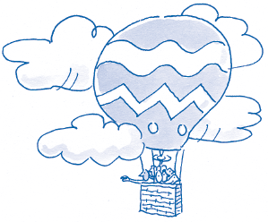

The motivation
Now, imagine you are in a television challenge. You are aloft in a balloon with these ten people. You will receive a prize of your choice (up to £5 million) if you can bring all ten people back to earth. Otherwise, you will be fined your income for a year. If you fail, they get a prize instead.

The challenge
However, you are only allowed to transport back any person if you can convince the audience that each person is really worth saving. You will need to show that you know about the person and can say things about them that bring out their best features.

For each person, use their name page to brainstorm responses to the following:
- what I like, value, admire, find interesting already about this person
- what I dislike about this person at present
- what this person contributes to the world that is different or valuable
- questions I could ask, to find out more
- anything I could do to develop a better understanding of this person.

 Balloon game
Jot down your thoughts on the following:

Which things you were less willing to do in this exercise? What was difficult and why?
In general, what kinds of people are you more likely to dismiss as ‘not your type of person’?

Who do you overlook? What kinds of things might you be missing out on because of that way of thinking? Are there ways that your current behaviour may come back to haunt you in the future? What effect might your behaviour be having upon other people?

